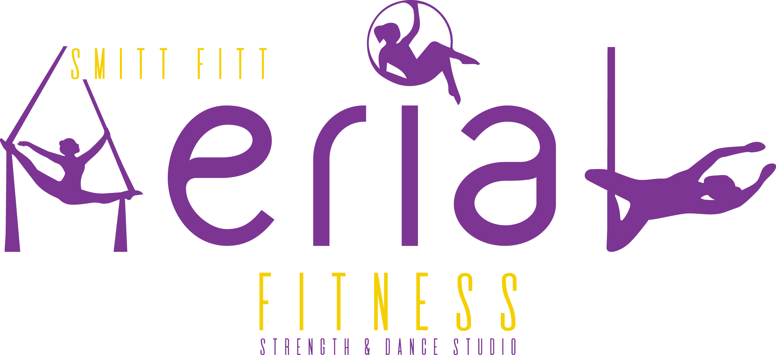

Privacy Policy

Smitt Fitt Aerial Fitness 497 0121 1591 has adopted this Privacy Policy to ensure we handle personal information in accordance with the National Privacy Principles set out in Schedule 3 of the Privacy Act 1988 (Cth) (“the Act”)
Collection of Personal Information

Type of Information
Consumer personal information is usually collected through enrolment forms, promotions, competitions, online shopping and consumer queries. The information may include:
Your full name, postal address, contact number(s) and email address information about your preference for goods or services we offer from time to time details of any prizes you may have won a record of any queries you have made your credit card details to process payments for enrolments and online orders.

Accessing Your Personal Information

You have a right to access your personal information, subject to exceptions allowed by law. If you would like to do so, please let us know. You may be required to put your request in writing for security reasons. Smitt Fitt Aerial Fitness reserves the right to charge a fee for searching for, and providing access to, your information on a per request basis.
Sharing of your personal information
We may occasionally hire other companies to provide services on our behalf, including but not limited to handling customer support enquiries, processing transactions or customer freight shipping. Those companies will be permitted to obtain only the personal information they need to deliver the service. Smitt Fitt Aerial Fitness takes reasonable steps to ensure that these organisations are bound by confidentiality and privacy obligations in relation to the protection of your personal information.

Changes to this Privacy Policy

Smitt Fitt Aerial Fitness reserves the right to make amendments to this Privacy Policy at any time. If you have objections to the Privacy Policy, you should not access or use the Site.

Accessing Your Personal Information
You have a right to access your personal information, subject to exceptions allowed by law. If you would like to do so, please let us know. You may be required to put your request in writing for security reasons.

Contact Us

Should you have any issues or concerns about your privacy please contact us.
Smitt Fitt Aerial Fitness
Kylie Smith
P. 0481 135 138
E. kylie@smittfittaerialfitness.com.au

