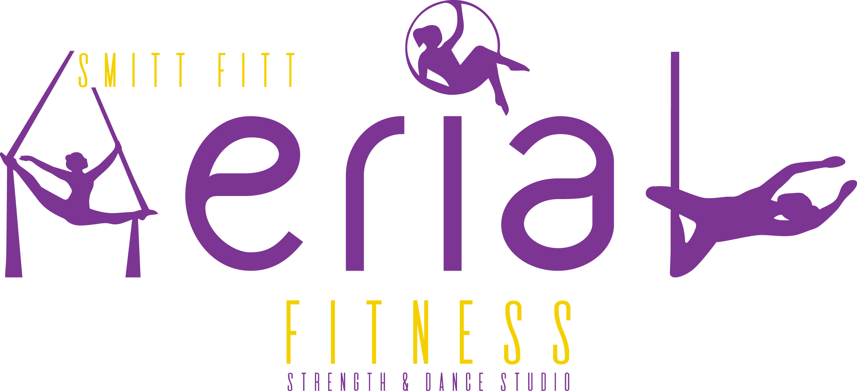
Please review the terms and conditions carefully. Release and Waiver of Liability: All clients agree to the following…
Health
Students are advised to consult with a physician with respect to any past or present injury, illness, pregnancy or any other health related condition or any kind whatsoever that may affect participation and ability to participate in the program. Students acknowledge that they have discussed the appropriateness of the pole dancing program in connection with any illness or condition that they have or have had with a physician, and that they knowingly execute this release from liability and negligence.
HEALTH IN RELATION TO COVID-19 :
- Students are advised NOT to attend class is they are feeling unwell.
- A handwashing sink is provided inside the studio and as well and hand sanitiser at both ends of the studio which we ask to be used upon entry.
- There will be NO SHARING of poles or doubles moves taught.
- Students will need to bring their own towel to wipe down poles before and after class. The studio will provide the metho bottles for each student which will be cleaned after each class. Extra towels/cloths will be available to purchase from the studio should you forget.
- Students are asked not to enter the studio while another pole class is running. We have given 10 minutes in between each class to clean and we ask that students wait in one of 2 places…. 1) in your car or outside the warehouse especially if there is a fitness class on at the same time. 2) Upstairs on the mezzanine floor making your way carefully up the stairs being mindful of the fitness class that may be running at the time. Instructors will open up curtains and ask for the next class to enter once the studio is ready.

Conduct
Students agree to the follow the directions of the instructor and that any misconduct or refusal by me to follow any direction of the instructor or rules of the studio can result in the cancellation of the lesson and the immediate removal from the class. I understand that such non-compliance may result in injury of any kind whatsoever as a result of my failure to comply. Rules of the studio are clearly displayed in dance areas.

Payments

Payments are to be made at the time of bookings and there are two (2) options. Upfront in full or one of our membership offers.

UPFRONT OPTION : Full term fees to be paid in full at the time of booking.

MEMBERSHIP OPTION : Direct debit form to be completed and handed to the studio within 24 hours of booking and first payment made immediately. All weekly payments will then be set up from week (two) 2 of the term on the nominated day.

Our bank details are as follows: NAB NAME: Kylie Smith BSB: 083 - 646 ACCOUNT NUMBER: 876-615-798 Please use your names as the reference.

Course Memberships

1 x Course $27.70 per week

2 x Courses $50 per week

3 x Course $75 per week

Or Packages…

1 x Course & I x Casual $40 per week

2 x Course & 1 x Casual $65 per week

3 x Course & 1 x Casual $90 per week.

Cancellations By The Studio
Smitt Fitt Aerial Fitness reserves the right to cancel class without notice. To ensure students do not miss out on a class we will either re-schedule or arrange a make up class.
Cancellations By Students
Smitt Fitt Aerial Fitness strongly recommends you attend all booked classes however we recognise and understand that sometimes there are events beyond our students control that will prevent them from attending class. Please note that Smitt Fitt Aerial Fitness offer no guarantee to provide you with a make up class due to student cancelations. We ask that where possible you provide us with Twenty Four (24) hours notice to cancel class. This gives other students who may be waiting for make up classes the option to take it. This also means it gives you the option should you be the one on our waiting list for a make up class. In the event whereby Smit Fitt Aerial Fitness cannot offer a student a make up class and the notice to cancel a class was given, the student will receive a voucher to use within two (2) weeks. Unfortunately a refund cannot be offered at any time.
Refunds
Refunds or the transfers of fees to another term will not be granted under any circumstances except for:
1) Courses cancelled due to student’s ill health are credited for the remainder value to be used within 12 months. In order to receive this credit you must give written notice and a medical certificate that confirms that sickness or incapacity. This will still remain at the discretion of Smitt Fitt Aerial Fitness Management.
2) Smitt Fitt Aerial Fitness reserves the right to change or cancel a class up to and including the date of the course if sufficient bookings have not been received. In the event of a class or course being cancelled, every effort will be made to avoid inconvenience by offering alternative dates and times. If we are not able to offer a suitable alternative class, a refund will only be granted at the discretion of Smitt Fitt Aerial Fitness Management.

Make Up Classes
Students who are eligible for a make up class (see the policy Student Cancelations) must ensure the class is used in the same term and cannot be transferred / rolled over to another term. All catch up classes must be booked to ensure there is a place available. No shows to classes will NOT be reimbursed or catch up classes given. Catch up classes must only be for the same course level or the level under and casual classes are not included.
Pregnancy
Smitt Fitt Aerial Fitness does not recommend that you participate in pole dancing whilst pregnant. In the event of an unexpected pregnancy prior to the course starting we will not refund any deposit paid unless we have 14 days notice prior to the commencement of the course. If the course has been paid in full and is less than 14 days notice before the commencement of the course, we may transfer the payment to another course within the 12 month period. This is at the discretion of Smitt Fitt Aerial Fitness Management.

Alcohol / Drug Consumption
Strictly no alcohol is to be consumed on the premises of Smitt Fitt Aerial Fitness. I understand and acknowledge the dangers associated with the consumption of alcohol or any mind altering drugs before and during the activity and take full responsibility for any injury, loss or damage associated with their consumption. I agree to not drink alcohol or take drugs prohibited by law before or during any activities conducted or organised by Smitt Fitt Aerial Fitness. I also agree that if I am taking painkillers for physical injuries then I should not participate in pole dancing until the pain is resolved.

Risk / Injury
Students understand, acknowledge and agree that the activities of pole dancing are dangerous and as such, have inherent dangers and risks, including risk of injury, permanent disability or death. Students acknowledge that the activities undertaken are at their own risk and therefore it would be unreasonable for Smit Fitt Aerial Fitness to be responsible in any way for any injury or any kind of death. Students hereby waive all legal rights of action against and fully release Smitt Fitt Aerial Fitness, it’s directors, instructors, employees, landlords and leases for the loss, damages or injuries arising out of or in relation to the participation by myself in the activities conducted or organised by Smitt Fitt Aerial Fitness. Including, without limitation, liability of any negligent or tortuous act or omission, breach of duty, breach of contract or breach of statutory duty on the part of Smitt Fitt Aerial Fitness or related parties. Students confirm that they assume the risk of, and the responsibility for any injury resulting from my participation in my activities. Students participate in activities at their sole risk and responsibility and release indemnify and hold harmless Smitt Fitt Aerial Fitness.

Intellectual Property
Smitt Fitt Aerial Fitness reserves the rights in all intellectual property, including but not limited to any moves, tricks, routines, course style and structure taught in any activities conducted or organised by Smitt Fitt Aerial Fitness. I understand and agree that I must not use or exploit any intellectual property owned by Smitt Fitt Aerial Fitness or personal financial gain in any manner, including but not limited to instructing or teaching pole dancing, without first obtaining the written permission of Smitt Fitt Aerial Fitness proprietors.

Minor Participation
Smitt Fitt Aerial Fitness recognises there may be students under the legal age of eighteen (18) years of age, and that the students may wish to attend or participate in Smitt Fitt Aerial Fitness classes. In the event that a student is under the legal age of consent, we require that the student’s parents and/or guardian sign the pole dancer enrolment form as well as the waiver and indemnity form on behalf of the student not of legal age.
Social Media
Smitt Fitt Aerial Fitness may take photos and/or videos from time to time for use on social pages. Please advise the studio at the time if you do not wish to be apart of the photos and/or videos. When filming and/or taking photos of your progress please be mindful of those around you and do not post photos and/or videos of others without their permission.
Assumption of Risk
By signing this waiver agreement the participant agrees to the following terms :
- The participant agrees that their participation in Smitt Fitt Aerial Fitness Classes is voluntary. Additionally, the participant agrees to assume any risk that is associated with participating in the event and releases Smitt Fitt Aerial Fitness from and all claims of damage and loss that may be as a result of participation. The release is without limitation and includes the personal injury fees, attorney’s fees and any other losses that might occur to the participant.
- The participant agrees to hold Smitt Fitt Aerial Fitness harmless against all claims and loss including damage to Smitt Fitt Aerial Fitness property caused by the participant.
- The participant hereby warrants that they are physically fit and able to participate in Smitt Fitt Aerial Fitness classes without any undue risk.
- Smitt Fitt Aerial Fitness maintains the right to refuse the participation in any classes if they foresee that the participation would risk damage to any party.
- This waiver agreement is governed by the laws of Victoria. Any legal claims or lawsuits related to the participants in any classes shall take place in Geelong, Victoria.
- The participant agrees that this waiver agreement shall remain in full force and take effect without change and that the participant in Smitt Fitt Aerial Fitness classes is pursuant to the terms and conditions.

Signature

Participants First and Last name ______________________________

Participants Signature ______________________________________

Date____________________________________________________

Signature on behalf of Smitt Fitt Aerial Fitness ___________________

Date ____________________________________________________

